March 2016
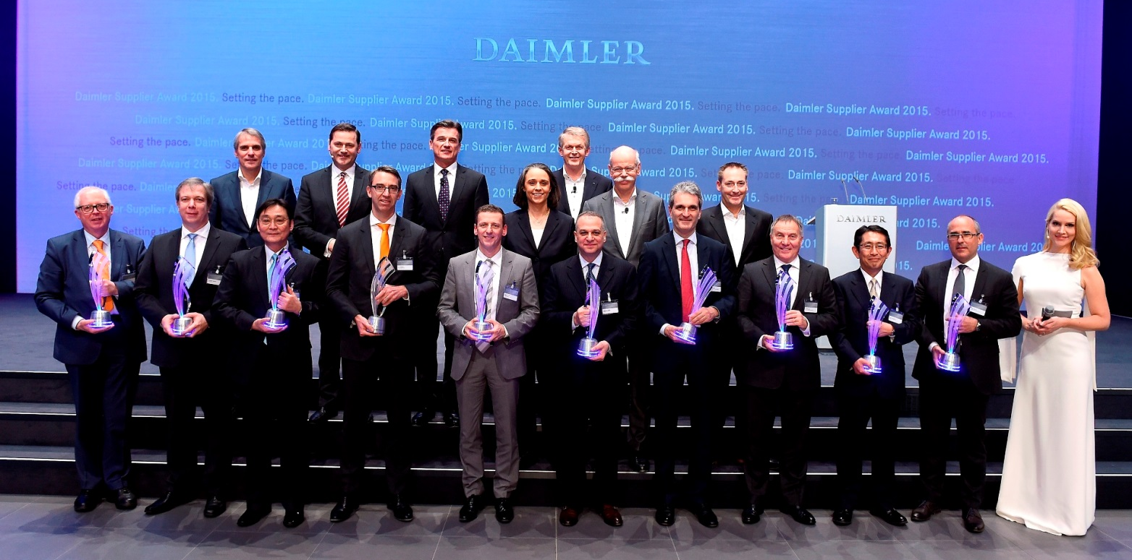
HELLER receives coveted Daimler Supplier Award 2015

Press relations
Gebr. Heller Maschinenfabrik GmbH

Marketing
Marcus Kurringer
Gebrüder-Heller-Straße 15
72622 Nürtingen
Germany
Phone: +49 7022 77-5683
Fax: +49 7022 77-165683
marcus.kurringer@heller.biz
HELLER receives coveted 2015 Daimler Supplier Award
Gebr. Heller Maschinenfabrik GmbH from Nürtingen has received the 2015 Daimler Supplier Award in the category “International Procurement Services” for supporting the automotive manufacturer in the further development and industrialisation of the innovative Nanoslide® process for the coating of cylinder bore surfaces of aluminium crankcases.
As a manufacturer of machine tools and complete manufacturing systems, HELLER has industrialised all steps of the coating process under the name HELLER CBC (CylinderBoreCoating), developing it into a dependable technology for global application in series production. HELLER not only integrates the process, including the process steps for
pre- and finish-machining, into the process chain in engine production, but also guarantees a correspondingly high level of process quality and reliability. By now, numerous systems have been installed successfully in Germany and Japan. International OEMs at more than 20 locations worldwide are planning to implement the new process technology in the coming years.
Daimler AG has honoured 10 suppliers for their outstanding performance in the past financial year with the 2015 Daimler Supplier Award. In front of an audience of around 450 invited guests from the supplier industry, the coveted prizes in the categories of Quality, Partnership and Innovation were awarded on 25 February 2016 at the Mercedes-Benz Branch in Stuttgart for the eighth time.

HELLER AT A GLANCE
Founded in: 1894 in Nürtingen
Employees: 2,530
Order intake 2014: EUR 558m
Turnover 2014: EUR 434m
Chairman of the Board: Berndt Heller
Managing Directors of the HELLER Group: Klaus Winkler, CEO
Manfred Maier, COO
Dieter Drechsler, Projects & Applications
Patrick Rimlinger, Operations
Dr. Jürgen Walz, Development
Regional Managing Directors: Christian Pfleiderer, HELLER Europa Sales & Services
Andrew Parkin, HELLER Asia
Keith Vandenkieboom, HELLER North America
Alfredo Griesinger, HELLER South America
Fields of business: 4-axis and 5-axis machining centres
Mill/turning centres
Flexible manufacturing systems
Machines for crankshaft and camshaft machining, CBC systems
Services
Production locations: Germany (Nürtingen)
United Kingdom (Reddich)
USA (Troy/Michigan)
Brazil (Sorocaba)
China (Changzhou)
Sales/Service locations: EUROPE
Germany (Hattingen, Salem, Goslar, Saarbrücken, Nuremberg, Nürtingen)
Italy (Verona) France (Paris)
Poland (Posen) Spain (Barcelona)
Sweden (Värnamo)
Switzerland (Niederbüren)
Slovakia (Vráble)
Russia (Moscow)
NORTH/SOUTH AMERICA
Mexico (Querétaro) Brazil (Belo Horizonte, Gravataí, Joinville)
ASIA
China (Beijing, Chongqing, Shanghai)
India (Pune)
Thailand (Bangkok)
Singapore

